# BEAUTY PARLOR MANAGEMENT SYSTEM

**A Project Report**

Project report Submitted in partial fulfillment of the requirement for

Award of the degree of

## BACHELOR OF SCIENCE (INFORMATION TECHNOLOGY)

**By**

Mr. Pratik shridhar chande

### Seat number- 603

### Under the guidance of

**Mr.R.R.Raut**



**DEPARTMENT OF INFORMATIOM TECHNOLOGY**

**VISHWABHUSHAN BHARATRATNA DR.BABASAHEB AMBEDKER**

## COLLEGE AMBADAVE, MANDANGAD

**(Affiliated to university of mumbai)**

**MUMBAI 400098. (2021-**

**2022)**

## PROFORMA FOR THE APPROVAL PROJECT PROPOSAL

**PRN No.: 2019016402067121 Roll No. :603**

**1.Name of the Student:** Pratik shridhar chande

1. **Title of the Project:** BEAUTY PARLOR MANAGEMENT SYSTEM.

1. **Name of the Guide: Prof. R.R.Raut**

1. **Teaching experience of the Guide:** 10 years.

|  |
| --- |
|  |

1. **Is this your first submission? Yes** **No**

**Signature of the Student Signature of the Guide**

**Date: ………………………… Date: …………………….**

**Signature of the Coordinator**

**Date: …………………………**

**VISHWABHUSHAN BHARATRATNA DR. BABASAHEB AMBEDKAR**

**COLLEGE AMBADAVE, MANDANGAD**

***(Affiliated to University of Mumbai)***

**MUMBAI 400098.**

**MAHARASHTRA**

**(2021-22)**

**DEPARTMENT OF INFORMATION TECHNOLOGY**



**CERTIFICATE**

This is to certify that the project entitled, **"BEAUTY PARLOR MANAGEMENT SYSTEM"**,is bonafied work of **Pratik shridhar chande** bearing Seat No:**603** submitted in partial fulfillment of therequirements for the award of degree of BACHELOR OF SCIENCE in INFORMATIONTECHNOLOGY from University of Mumbai.

**Internal Guide Coordinator**

**External Examiner**

**Date: College Seal**

## ROLES AND RESPONSIBILITIES FORM

**Name of the Project: - Beauty Parlor Management System.** **Date:**

|  |  |  |
| --- | --- | --- |
| Name of Member | Role | Task and Responsibilities |
| **Pratik shridhar chande** | Team Coordinator | Coordinating the Project. Maintaining milestones and regulation related to the project. |
| Auditor/ Receiver | Checking the project related documents are maintained properly. Update latest information of the project. |
| Data Manager | Maintaining record and information related and discussion related to the project. |
| Quality manager | Maintaining records and information related to quality assurance in the project. |

Name and Signature of the **Project members:**

**Name: -1) Pratik shridhar chande**  **Signature____________________**

Signature of the Counsellor:

**Signature____________________**

**Date:**

**ABSTRACT**

Project on **Beauty Parlour Management System.** There is the need for efficient management of a web-based system for handling a customer.

This project is an endeavour to provide a solution to this. The proposed system enables an administrator to keep track of customer, Dealer and maintaining records of the customers and Dealers. He can view the submitted requirements made by the customer. He can also view the reports generated by him and also sent approvals or rejection instantly.

Thus, a project is a sincere effort in simplifying the task of administrator in an easily usable format.

# ACKNOWLEDGEMENT

The Project Title **Beauty Parlor Management System** is prepared by **Mr.pratik shridhar chande** of T.Y.BSc**[ Information Technology], V.B.D.B.A College , Ambadave.** This has been prepared under the program for Degree Course.

We take immense pleasure in acknowledging the kind support selflessly to us by college faculty and friends.

The other person that needs very special mention is our project guide and Prof. of B.Sc.I.T. **Mr.R.R.Raut** He has been the driving force behind the enthusiasm and the hard work throughout this project.

We would also like to thank our other teachers, faculty members and friends for being helping in the project. Their valuable inputs helped us in this project better.

**Mr.pratik shridhar chande**

**(T.Y.Bsc.I.T)**

# DECLARATION

I hereby declare that the project entitled, “Beauty Parlour Management System” done at VishwabhushanBharatratnaDr.Babasaheb Ambedkar College Ambadave, has not been in any case duplicated to submit to any other university for the award of any degree. To the best of my knowledge other than me, no one has submitted to any other university.

The project is done in partial fulfilment of the requirements for the award of degree of

**BACHELOR OF SCIENCE (INFORMATION TECHNOLOGY) to be submitted** as final semester project as part of our curriculum.

**Pratik shridhar chande**

**(T.Y.BSc.IT)**

## Index

|  |  |  |  |
| --- | --- | --- | --- |
| Sr.no |  | Topic | Page no. |
| **Chapter 1.** |  | **1.Introduction** |  |
|  | **1.1** | **Background** |  |
|  | **1.2** | **Objectives** |  |
|  | **1.3** | **Purpose, Scope and Applicability** |  |
|  | **1.4** | **Achievements** |  |
| **Chapter 2.** |  | **2.Survey of Technology** |  |
|  | **2.1** | **Survey of Technology** |  |
|  | **2.2** | **Existing system** |  |
|  | **2.3** | Proposed System & Advantage |  |
| **Chapter 3.** |  | **3.Requirement and analysis** |  |
|  | **3.1** | **Problem Definition** |  |
|  | **3.2** | **Requirements Specification** |  |
|  | **3.3** | **Planning and Scheduling** |  |
|  | **3.4** | **Software and Hardware Requirements** |  |
|  | **3.5** | **Preliminary Product Description** |  |
|  | **3.6** | **Conceptual Model** |  |
| **Chapter 4.** |  | **System Design** |  |
|  | **4.1** | **Basic Model** |  |
|  | **4.2** | **Data Design** |  |
|  | **4.3** | **User interface Design** |  |
|  | **4.4** | **Security Issues** |  |
|  | **4.5** | **Test Cases Design Test log** |  |
| **Chapter 5.** |  | **IMPLEMENTATION AND TESTING** |  |
|  | **5.1`** | **Implementation Approaches** |  |
|  | **5.2** | **Coding Details and Code Efficiency** |  |
|  | **5.3** | **Testing Approach** |  |
| **Chapter 6.** |  | **RESULTS AND DISCUSSIONS** |  |
|  | 6.1 | Test Reports |  |
| **Chapter 7.** |  | **Feature Enhancement ,Conclusion &**  **Reference** |  |

## List of Figures

|  |  |  |  |
| --- | --- | --- | --- |
| Sr.  No. | Figure No. | Figure Name | Page No. |
| 1 | 3.6.1 | ER-Diagram |  |
| 2 | 3.6.2 | Use Case for Customer |  |
| 3 | 3.6.3 | Use Case for User |  |
| 4 | 3.6.4 | DFD Diagram 0-Level |  |
| 5 | 3.6.5 | DFD Diagram 1-Level |  |
| 6 | 3.6.6 | DFD Level Diagram |  |
| 7 | 3.6.7 | Activity Diagram |  |
| 8 | 3.6.8 | Class Diagram |  |

**List of Tables**

|  |  |  |  |
| --- | --- | --- | --- |
| **Sr. No.** | **Figure No.** | **Figure Name** | **Page No.** |
| 1 | 4.1 | Customer Login |  |
| 2 | 4.2 | Customer Registration (For Create new account) |  |
| 3 | 4.3 | Home Page |  |
| 4 | 4.4 | Appointment Booking |  |
| 5 | 4.5 | Therapy Details |  |
| 6 | 4.6 | Appointment Cancellation |  |
| 7 | 4.7 | Customer Feedback |  |
| 8 | 4.8 | Admin Registration |  |
| 9 | 4.9 | Admin Login |  |
| 10 | 4.10 | Admin Home ( For information about Customer  Details) |  |

# CHAPTER 1

**INTRODUCTION**

## INTRODUCTION

**1.1Background**

Beauty parlor management system is developed to automate all the parlor activity. Using this system user can manage their salon and also use this system to book appointment of his customer online. Users can click on the parlor’s name in order to get the address and phone number of the parlor. Customer can login into the system by giving valid username and password. After login he can check his upcoming appointments. salon admin can also how many appointment they have to complete on particular date. User can also search parlor by entering its name in the search box.

**1.2Objective**

The Proposed System ensures the complete freedom for users, where user at his own system can log on to his website and can book his ticket.

* Our proposed system allows only registered users to book an Appointment, view timing and cancel their Appointment.

* In this proposal the entire work is done on online.

* Here customers can send their queries and suggestions through a feedback form.

* 24 hour booking system, once a client has booked a confirmation email is sent to their ID mobile, tablets and PCs to add a personal touch that displays your commitment to customer service.

* Users can access the booking system from anywhere in the world and keep up to date in the real time.

**1.3Purpose, Scope and Applicability:**

In present system you have to call the beauty parlor to fix an appointment. After taking an appointment you have to remember the date of the appointment. In current system salon take appointment on register.

They manage customer record on register. And it is very difficult to find out old appointment details in this system. Making report for the parlor business is also very tiresome task. this system is prone to costly human error. Beauty parlor management system allow salon to manage stylists and services, promote sales to customers, and track customer satisfaction

### 1.4Achievement

* Proposed System Is Computerized System with avoids of Limitation of Current System.

* If we want to search any past record, then we can get that record in very short Time.

* This system will provide timely report information.

* The computer can holds amount of data in its storage device.

* We can calculate results and report within seconds.

**CHAPTER 2**

**SYSTEM ANALYSIS**

## 2.1Existing System

In present system you have to call the beauty parlor to fix an appointment. After taking an appointment you have to remember the date of the appointment. In current system salon take appointment on register.

They manage customer record on register. And it is very difficult to find out old appointment details in this system. Making report for the parlor business is also very tiresome task. This system is prone to costly human error.

Beauty parlor management system allow salon to manage stylist and service, promote sales to customer satisfaction.

## 2.2Proposed System

* The Proposed System ensures the complete freedom for user, when user at her own system can log on to his website and book her appointment.

* Our proposed system allows only registration user to book an Appointment, view timing and cancel their Appointment.

* In this proposal the entire work is done on online.

* Here customer can sent their queries and suggestion through a feedback form.

* 24 hour booking system, once a client has booked a confirmation email is send to their ID mobiles, tablets and PCs to add personal touch that displays your commitment to customer service.

* User can access the booking system from anywhere in the world and keep up to date in the real time.

* Its save more time and cost.

## 2. 3 REQUIREMENTS AND ANALYSIS

### Problem Definition

The existing Beauty Parlor Management System was not very effective and was highly time consuming. The system was worked manually.

The rate at which the work done is very slow due to non-utilization of computerized system. It does not provide better data availability on fingerprint. It is difficult to remember all data. Difficulty in managing multiple forms.

Some difficulties are obtained in existing system are :-

1. Lack of Security.

1. All data filling and managing details are manually.

1. The register record make a manual that may occurs mistakes in the data.

1. Difficult managing the forms such the therapy details forms, user forms.

Then the difficult managing and remembering the data or records.

## Requirement Specification

In the organization or market requirement its shop need to a fully automate its corresponding facilities and obtained activities.

In the organization or in the market may require the proposed software are as follows.

1. In the system to keep and managing the computer or other product and accessories details.

1. To keep and record the company details.

1. Record the form of users details.

1. Maintains the forms of therapy details.

The billing price is to managing easy and non-complicated in that system. And all the data make secure in that system.

### 2.4 Software and Hardware Requirements

HARDWARE (Recommended)

* Processor:-dual core and above.

* Hard disk Capacity:-20GB.

* RAM:-1GB.

SYSTEM (Recommended)

* Framework:- Net Framework 4.0

* Database:- MS SQL Server Express Edition

* Operating System:- Windows 10

### 3.3 Planning and Scheduling : Gantt chart

|  |  |  |  |  |  |
| --- | --- | --- | --- | --- | --- |
| **Phase** | | **Sub phase** | **Expected Date of Completion** | **Actual Date of Completion** | **Remarks** |
| **Preliminary**  **Investigation** | |  |  |  |  |
|  | | Organizational  Overview | 22/06/2019 | 23/06/2019 |  |
| System  Description | 10/07/2019 | 10/07/2019 |  |
| Feasibility Study | 22/07/2019 | 23/07/2019 |  |
| **System Analysis** | |  |  |  |  |
|  |  | Collection of  System  Requirements | 05/08/2019 | 08/08/2019 |  |
| Modeling Events | 24/08/2019 | 29/08/2019 |  |
| Modeling  Classes/objects | 07/09/2019 | 13/09/2019 |  |
| Identifying  Activities &  Sequence | 24/09/2019 | 26/09/2019 |  |
| **System Designing** |  |  | |  | |
|  |  | Designing  Database Tables | 30/09/2019 | 30/10/2019 |  |
|  |  | Components,  Package &  Deployment considerations | 01/10/2019 | 5/10/2019 |  |
| **System Coding** |  |  | |  | |
|  |  | Program Coding | 31/12 2019 | 05/01/2020 |  |
| Testing &  Validations | 28/01/2020 | 29/01/2020 |  |
| System  Integration | 18/02/2020 | 21/02/2020 |  |
| **System**  **Implementation** |  |  | 11/03/2020 | 19/03/2020 |  |
| **Project Review**  **Guide** | **by** |  | 20/03/2020 | 21/03/2020 |  |
| **Feedback for**  **Improving ,correcting**  **& Modifying the**  **Project** | |  | 25/03/2020 | 29/03/2020 |  |
| **Project Report submission** | |  | 01/04/2020 | 05/04/2020 |  |

**2.6Justification of selection of Technology**

#### MICROSOFT VISUAL STUDIO 2015

Microsoft visual studio is a integrated development environment (IDE) from Microsoft. This IDE used in this “Beauty Parlor Management System” MCROSOFT ASP.Net 4.5

ASP.NET is web application framework developed and marketed by Microsoft to allow Programmers to build dynamic web site, web applications and web services.

This framework used in designing of the system.

BACKENDE

##### MICROSOFT SQL Server 2010

Microsoft SQL server is a computer application used to create desktop, enterprise, and web based database systems. Provides an environment used to generate database that can be accessed from workstation & internet. This server used in create back end of the system.

**CHAPTER 3**

## SYSTEM DESIGNING

### 3.1 Basic Modules

####  Admin/Customer

In that module the user edits or fill-up information about the customer. Customer details from consist add customer, update Customer, delete customer.

####  Appointment

This module consist the Appointment details.

All the details of the Appointment are user can be entered in this form. This page is used for enter the details of Appointment.

####  Therapy

In that module user create a Therapy Rate for Customer, product, MRP, total amount etc.

❖ **Feedback**

Feedback module is used to display the feedback information.

## 3.2Data Dictionary

**LOGIN TABLE:**

|  |  |  |  |
| --- | --- | --- | --- |
| **ATTRIBUTE**  **NAME** | **DATA TYPE** | **CONSTRAINS** | **SAMPLE VALUE** |
| Username | Varchar2(20) | Primary Key | Merry |
| Password | Varchar2(20) | Check | Merry 1998 |

**REGISTRATION TABLE:**

|  |  |  |  |
| --- | --- | --- | --- |
| **ATTRIBUTE**  **NAME** | **DATA TYPE** | **CONSTRAINS** | **SAMPLE VALUE** |
| Username | Varchar2(20) | Primary Key | Merry |
| Password | Varchar2(20) | Check | Merry 1998 |
| First name | Varchar2(10) | Not null | Merry |
| Last name | Varchar2(20) | Not null | Ravva |
| Email | Varchar2(50) | Not null | merry.ravva@gmail.com |
| Contact No. | Varchar2(50) | Not null | 7066122033 |

**APPOINTMENT TABLE:**

|  |  |  |  |
| --- | --- | --- | --- |
| **ATTRIBUTE**  **NAME** | **DATA TYPE** | **CONSTRAINS** | **SAMPLE VALUE** |
| Customer Name | Varchar2(20) | Foreign Key | Merry |
| Email ID | Varchar2(50) | Not null | merry.ravva@gmail.com |
| Date & Time | Varchar2(10) | Not null | 03/01/2019 02.30pm |
| Therapy Name | Varchar2(50) | Not null |  |

**THERAPY TABLE:**

|  |  |  |  |
| --- | --- | --- | --- |
| **ATTRIBUTE**  **NAME** | **DATA TYPE** | **CONSTRAINS** | **SAMPLE VALUE** |
| Therapy ID | Varchar2(20) | Primary Key | Mud Bath |
| Time | Varchar2(50) | Not null | 02.30pm |
| Rate | Varchar2(10) | Not null | 1000 |

**APPINTMENT CANCELLATION TABLE:**

|  |  |  |  |
| --- | --- | --- | --- |
| **ATTRIBUTE NAME** | **DATATYPE** | **CONSTRAINS** | **SAMPLE VALUE** |
| User_Name | Varchar2(20) | Primary Key | Jeny |
| Appintment_Date | Varchar2(50) | Not null | 2September |
| Cancellation_Date | Varchar2(10) | Not null | 30August |
| Therapy | Varchar2(50) | Not null | Mud Bath |

**FEEDBACK TABLE:**

|  |  |  |  |
| --- | --- | --- | --- |
| **ATTRIBUTE**  **NAME** | **DATATYPE** | **CONSTRAINS** | **SAMPLE VALUE** |
| Customer Name | Varchar2(20) | Primary Key | Merry |
| Message | Varchar2(MAX) | Null | Some text message here |

**3.3 CONCEPTUAL MODELS**

### ER Diagram



Fig. ER Diagram

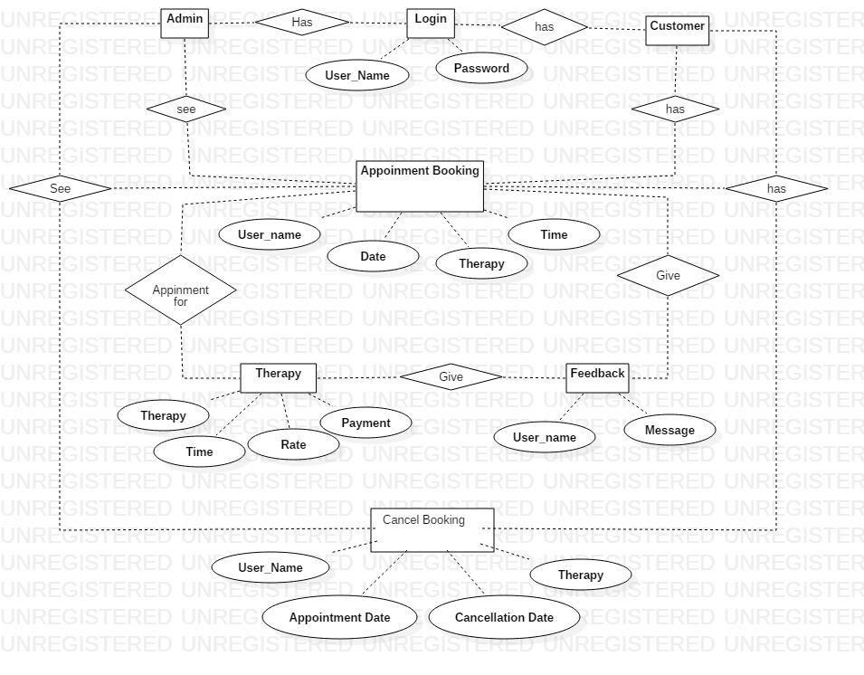

**Use Case Diagram**



**Fig. Use Case for Admin**

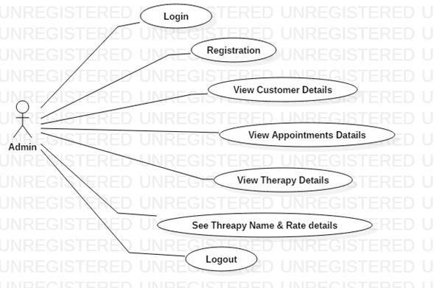

**Use Case User Module**



Fig. Use Case for Customer

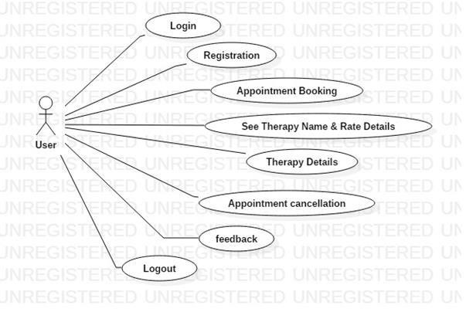

**3.4 Data Flow Diagram**

Fig. 0

-

Level DFD

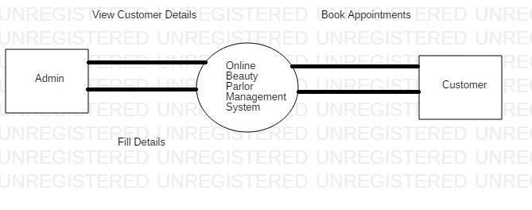

First Level DFD



Fig. First Level DFD

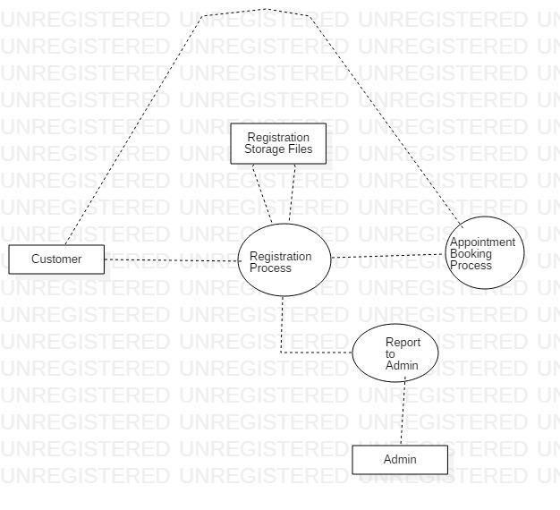

Second Level DFD

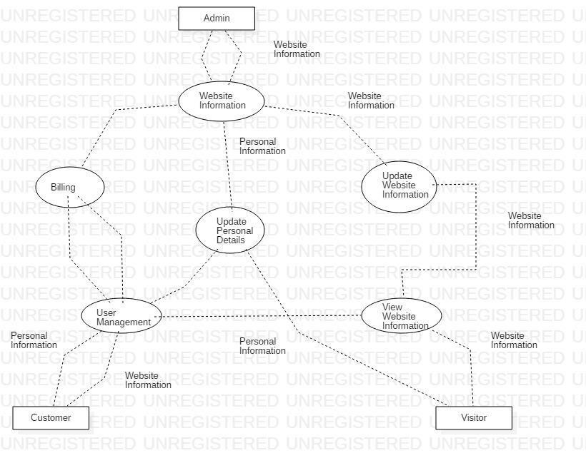

Fig. Second Level DFD

**Activity Diagram**



Fig.



Activity Diagram

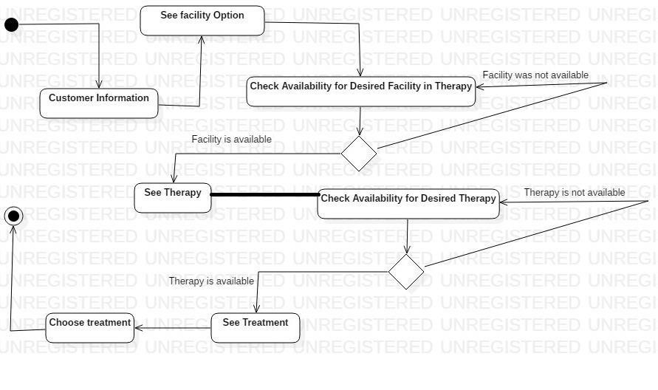

Class Diagram

Fig. Class Diagram

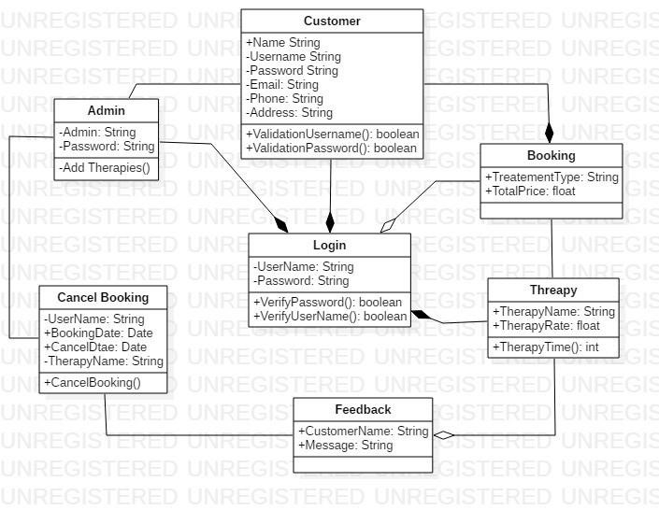

## Chapter 4

### IMPLEMENTATION AND TESRTING

**4.1Code**

**SOURCE CODE:**

#### CUSTOMER LOGIN:-

using System; using System.Collections.Generic; using System.Linq; using System.Web; using System.Web.UI; using System.Web.UI.WebControls; using System.Data; using System.Data.SqlClient; public partial class Login : System.Web.UI.Page

{

SqlConnection con = new SqlConnection("Data

Source=(LocalDB)\\MSSQLLocalDB;AttachDbFilename=|DataDirectory|\\Parlor

System.mdf;Integrated Security=True"); protected void Page_Load(object sender, EventArgs e)

{ } protected void Button1_Click(object sender,

EventArgs e)

{

/* con.Open();

string query = "insert into [Login] values('" + TextBox1.Text + "','" + TextBox2.Text + "')";

SqlCommand cmd = new SqlCommand(query, con); cmd.ExecuteNonQuery(); con.Close();

Response.Redirect("HomePage.aspx");*/

} protected void TextBox1_TextChanged(object sender,

EventArgs e)

{

} protected void Button2_Click(object sender,

EventArgs e)

{

/* Response.Redirect("Registration.aspx");*/

} protected void Button3_Click(object sender,

EventArgs e)

{ } protected void ImageButton2_Click(object sender,

ImageClickEventArgs e)

{ string selectSQL = "SELECT * FROM

Login";

// Define the ADO.NET objects. SqlConnection con = new SqlConnection(connectionString);

SqlCommand cmd = new SqlCommand(selectSQL, con);

SqlDataReader reader;

// Try to open database and read information.

try

{

con.Open();

reader = cmd.ExecuteReader();

// For each item, add the author name to the displayed

// list box text, and store the unique ID in the Value property.

while (reader.Read())

{

ListItem newItem = new ListItem(); string uname = reader["User_Name"].ToString(); string pass = reader["Password"].ToString(); if

(uname == TextBox1.Text && pass == TextBox2.Text)

{

Response.Redirect("HomePage.aspx");

} else { Label5.Text="Wrong password";

}

} reader.Close();

} catch

(Exception err)

{ } con.Close(); } protected void

ImageButton3_Click(object sender, ImageClickEventArgs e)

{

Response.Redirect("Registration.aspx");

}

}

#### CUSTOMER REGISTRSTION:-

using System; using System.Collections.Generic; using System.Linq; using System.Web; using System.Web.UI; using System.Web.UI.WebControls; using System.Data; using System.Data.SqlClient; public partial class Registration :

System.Web.UI.Page

{

SqlConnection con = new SqlConnection("Data

Source=(LocalDB)\\MSSQLLocalDB;AttachDbFilename=|DataDirectory|\\Parlor

System.mdf;Integrated Security=True"); protected void Page_Load(object sender, EventArgs e) {

} protected void Button2_Click(object sender,

EventArgs e)

{

Response.Redirect("Login.aspx");

} protected void Button1_Click(object sender,

EventArgs e)

{

Response.Redirect("HomePage.aspx");

} protected void Button3_Click(object sender,

EventArgs e) { con.Open();

string query = "insert into [Registration] values('" + TextBox1.Text +

"','" + TextBox2.Text + "','" + TextBox3.Text + "','" + TextBox4.Text +

"','" + TextBox5.Text + "','" + TextBox6.Text + "')"; SqlCommand cmd = new SqlCommand(query, con); cmd.ExecuteNonQuery(); con.Close(); Response.Redirect("HomePage.aspx");

} protected void ImageButton2_Click(object sender,

ImageClickEventArgs e)

{

Response.Redirect("HomePage.aspx");

} protected void ImageButton1_Click(object sender,

ImageClickEventArgs e)

{ } protected void TextBox6_TextChanged(object sender,

EventArgs e)

{

}

}

##### Appointment Booking:-

using System; using System.Collections.Generic; using

System.Linq; using System.Web; using System.Web.UI; using

System.Web.UI.WebControls; using System.Data; using

System.Data.SqlClient; public partial class

Appiontment_Booking : System.Web.UI.Page

{

SqlConnection con = new SqlConnection("Data

Source=(LocalDB)\\MSSQLLocalDB;AttachDbFilename=|DataDirectory|\\Parlor

System.mdf;Integrated Security=True"); protected void Page_Load(object sender, EventArgs e)

{ } protected void Button1_Click(object sender,

EventArgs e) { con.Open();

string query = "insert into [Appointment Booking] values('" +

TextBox1.Text + "','" + TextBox2.Text + "','" + TextBox3.Text + "','" + TextBox4.Text + "')";

SqlCommand cmd = new SqlCommand(query, con); cmd.ExecuteNonQuery(); con.Close();

Response.Redirect("Therapy Details.aspx");

} protected void ImageButton1_Click(object sender,

ImageClickEventArgs e)

{

Response.Redirect("Therapy and Rate Details.aspx");

} protected void Button2_Click(object sender,

EventArgs e) {

Response.Redirect("Therapy and Rate Details.aspx");

} protected void ImageButton1_Click1(object sender,

ImageClickEventArgs e)

{ con.Open();

string query = "insert into [Appointment Booking] values('" + TextBox1.Text + "','" + TextBox2.Text + "','" + TextBox3.Text + "','" + TextBox4.Text + "')";

SqlCommand cmd = new SqlCommand(query, con); cmd.ExecuteNonQuery(); con.Close();

Response.Redirect("Therapy Details.aspx");

}

}

##### Therapy Details:-

using System; using System.Collections.Generic; using System.Linq; using System.Web; using System.Web.UI; using System.Web.UI.WebControls; using System.Data; using System.Data.SqlClient; public partial class Therapy : System.Web.UI.Page

{

SqlConnection con = new SqlConnection("Data

Source=(LocalDB)\\MSSQLLocalDB;AttachDbFilename=|DataDirectory|\\Parlor

System.mdf;Integrated Security=True"); protected void Page_Load(object sender, EventArgs e)

{ } protected void Button1_Click(object sender,

EventArgs e) { con.Open(); string query = "insert into [Therapy Details] values('" +

TextBox1.Text +

"','" +

TextBox2.Text + "','" +

TextBox3.Text +

"')"; SqlCommand cmd = new

SqlCommand(query, con); cmd.ExecuteNonQuery (); con.Close();

Response.Redirect("Appointment Cancellation.aspx");

}

}

##### Appointment Cancellation:-

using System; using System.Collections.Generic; using System.Linq; using System.Web; using System.Web.UI; using

System.Web.UI.WebControls; using System.Data; using System.Data.

SqlClient; public partial class Appointment_Cancellation :

System.Web.UI.Page

{

SqlConnection con = new SqlConnection("Data

Source=(LocalDB)\\MSSQLLocalDB;AttachDbFilename=|DataDirectory|\\Parlor

System.mdf;Integrated Security=True"); protected void Page_Load(object sender, EventArgs e)

{ } protected void Button1_Click(object sender,

EventArgs e) { con.Open();

string query = "insert into [Appointment Cancellation] values('" +

TextBox1.Text + "','" + TextBox2.Text + "','" + TextBox3.Text + "','" TextBox4.Text + "')";

SqlCommand cmd = new SqlCommand(query, con); cmd.ExecuteNonQuery(); con.Close();

Response.Redirect("Feedback.aspx");

} protected void ImageButton1_Click(object sender,

ImageClickEventArgs e) { con.Open();

string query = "insert into [Appointment Cancellation] values('" +

TextBox1.Text + "','" + TextBox2.Text + "','" + TextBox3.Text + "','" + TextBox4.Text + "')";

SqlCommand cmd = new SqlCommand(query, con); cmd.ExecuteNonQuery(); con.Close(); Response.Redirect("Feedback.aspx");

}

}

##### Feedback:-

using System; using System.Collections.Generic; using System.Linq; using System.Web; using System.Web.UI; using System.Web.UI.WebControls; using System.Data; using System.Data.SqlClient; public partial class Feedback : System.Web.UI.Page

{

SqlConnection con = new SqlConnection("Data

Source=(LocalDB)\\MSSQLLocalDB;AttachDbFilename=|DataDirectory|\\Parlor System.mdf;Integrated Security=True"); protected void Page_Load(object sender, EventArgs e)

{ } protected void Button1_Click(object sender,

EventArgs e) { con.Open(); string query = "insert into [Feedback] values('" +

TextBox1.Text +

"','" + TextBox2.Text + "')"; SqlCommand cmd = new SqlCommand(query, con); cmd.ExecuteNonQuery(); con.Close();

} protected void TextBox1_TextChanged(object sender,

EventArgs e)

{ } protected void ImageButton1_Click(object sender,

ImageClickEventArgs e) { con.Open();

string query = "insert into [Feedback] values('" + TextBox1.Text + "','" + TextBox2.Text + "')";

SqlCommand cmd = new SqlCommand(query, con); cmd.ExecuteNonQuery(); con.Close();

} protected void Menu1_MenuItemClick(object sender,

MenuEventArgs e)

{

}

}

##### ADMIN LOGIN:-

using System; using System.Collections.Generic; using System.Linq; using System.Web; using System.Web.UI; using System.Web.UI.WebControls; using System.Data; using System.Data.SqlClient; public partial class Login : System.Web.UI.Page

{

SqlConnection con = new SqlConnection("Data

Source=(LocalDB)\\MSSQLLocalDB;AttachDbFilename=|DataDirectory|\\Parlor System.mdf;Integrated Security=True"); protected void Page_Load(object sender, EventArgs e)

{ } protected void Button1_Click(object sender,

EventArgs e)

{

/* con.Open();

string query = "insert into [Login] values('" + TextBox1.Text + "','" + TextBox2.Text + "')";

SqlCommand cmd = new SqlCommand(query, con); cmd.ExecuteNonQuery(); con.Close();

Response.Redirect("HomePage.aspx");*/

} protected void TextBox1_TextChanged(object sender,

EventArgs e)

{ } protected void Button2_Click(object sender,

EventArgs e)

{

/* Response.Redirect("Registration.aspx");*/

} protected void Button3_Click(object sender,

EventArgs e)

{ } protected void ImageButton2_Click(object sender,

ImageClickEventArgs e)

{ string selectSQL = "SELECT * FROM

Login";

// Define the ADO.NET objects. SqlConnection con = new SqlConnection(connectionString);

SqlCommand cmd = new SqlCommand(selectSQL, con);

SqlDataReader reader;

// Try to open database and read information.

try

{ con.Open(); reader = cmd.ExecuteReader();

// For each item, add the author name to the displayed

// list box text, and store the unique ID in the Value property. while (reader.Read())

{

ListItem newItem = new ListItem(); string uname = reader["User_Name"].ToString(); string pass = reader["Password"].ToString(); if

(uname == TextBox1.Text && pass == TextBox2.Text)

{

Response.Redirect("HomePage.aspx");

} else

{

Label5.Text="Wrong password";

}

} reader.Close();

} catch

(Exception err)

{ } con.Close();

} protected void ImageButton3_Click(object sender,

ImageClickEventArgs e)

{

Response.Redirect("Registration.aspx");

}

}

##### ADMIN REGISTRATION:-

using System; using System.Collections.Generic; using System.Linq; using System.Web; using System.Web.UI; using System.Web.UI.WebControls; using System.Data; using System.Data.SqlClient; public partial class Admin_Registration :

System.Web.UI.Page

{

SqlConnection con = new SqlConnection("Data

Source=(LocalDB)\\MSSQLLocalDB;AttachDbFilename=|DataDirectory|\\Parlor

System.mdf;Integrated Security=True"); protected void

Page_Load(object sender, EventArgs e)

{

} protected void Button1_Click(object sender,

EventArgs e)

{

/*con.Open(); string query = "insert into [Admin Registration] values('" + TextBox1.Text +

"','" + TextBox2.Text + "','" + TextBox3.Text + "','" + TextBox4.Text + "','" + TextBox5.Text + "','" + TextBox6.Text + "')"; SqlCommand cmd = new SqlCommand(query, con); cmd.ExecuteNonQuery(); con.Close();*/

}

protected void Button2_Click(object sender, EventArgs e)

{

Response.Redirect("Customer Details.aspx");

} protected void Button3_Click(object sender,

EventArgs e)

{

Response.Redirect("Appointments Details.aspx");

} protected void ImageButton1_Click(object sender,

ImageClickEventArgs e) { con.Open(); string query = "insert into [AdminLogin] values('" + TextBox1.Text + "','" +

TextBox2.Text + "','" + TextBox3.Text + "','" + TextBox4.Text + "' )"; SqlCommand cmd = new SqlCommand(query, con); cmd.ExecuteNonQuery(); con.Close();

Label6.Text = "record inserted";

} protected void TextBox4_TextChanged(object sender,

EventArgs e)

{

}

}

#### 4.2 Testing Approach Testing

**Testing Plan**

Testing is very vital for any system to be successfully implemented. The common view is that it is performed to prove that there are no errors in a program. Therefore the most useful and practical approach is with the explicit intention of finding the errors. The system is tested experimentally to ensure that the software is does not fail. The system is run according to its specification and in the way the user expects. Following testing practices are used. The system will process as normal input preparation of testsample data.

**Testing Approach:**

##### 4.2.1 Unit Testing

It is a level of software testing where individual units/components of software are tested. The purpose is to validate that each unit of the software performs as designed. A unit is the smallest testable part of software. It usually has one or few inputs and usually a single output. In procedural programming a unit may be an individual program. Function, procedure, etc. In object oriented programming, the smallest unit in method, which may belong to a base/ super class, abstract class or derived/ child class.

* The software consists of different modules

* The modules were tested as the development process was complete.

* The testing was carried on by the developer himself.

* The testing consisted of checking the module for trivial as well as major errors.

* Errors that were detected were worked upon, thus making the software error free.

### 4.2.1Test Case Design

|  |  |  |  |
| --- | --- | --- | --- |
| **Reno.** | **Test Case**  **ID** | **Do** | **Expected Result** |
| 1. | 001 | Enter user name in the text Box specified    User name must not be more than  20 characters and it should not contain any special characters and  no spaces including in the start.    Enter Password in the text box specified. Password must not be more than 10 characters.    Click on the Login button. | Successful login in to    The system if the values are found in the database |
| 2. | 002 | User Name  First Name,  Last Name,  Contact No,  Email Id,  Password | Successfully Showing result  Information about    User Name  First Name,  Last Name,  Contact No,  Email Id,  Password, |
| 3. | 003 | User Name  Therapy,  Date,  Time | Showing the result of successfully enter the all data in that form |
| 4. | 004 | Therapy Name,  Time,  Rate | Showing the result of successfully enter the all data in that form |
| 5. | 005 | User Name,  Appointment Date,  Cancellation Date, | Successfully Showing the result in to the system |
|  |  | Therapy |  |
| 6. | 006 | User Name, Message | Thank you for your Feedback |

#### 4.2.2 Integration Testing

It is level of software testing where individual units are combined and tested as a group. The purpose of this level of testing is to expose fault in the interaction between integrated units. Test drivers and test stubs are used to assist in integration testing.

Testing performed to expose defects in the interface and in the interaction between integrated component or system is known as integration testing.

* Integration testing was carried out after the completion of unit testing.

* All the units, modules were integrated as single system and tested in unison.

* The testing was carried out by the developer team.

* Error that was detected were worked upon and corrected.

### Test log

|  |  |  |  |  |
| --- | --- | --- | --- | --- |
| **Function** | **Purpose of Set of**  **Test Case paper Area** | **Test Case ID(s)** | **Noof Test Cases run** | **Number of**  **TestCases**  **Successful** |
| Login | The verification of username and password | 001 | 8 | 100% |
| Registration Form | Data entry of the details of customer | 002 | 8 | 100% |
| Appointment form | Data entry of the details of  Appointment | 003 | 8 | 100% |
| Feedback | Data entry of the details of Feedback | 004 | 8 | 100% |

### CHAPTER 5

**RESULTS AND DISCUSSION**

**User interface design**

|  |  |
| --- | --- |
| **Customer Form** | LOGIN FORM |
|  | |

REGISTRATION FORM

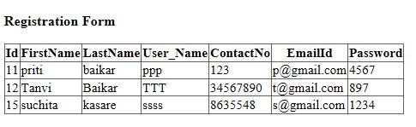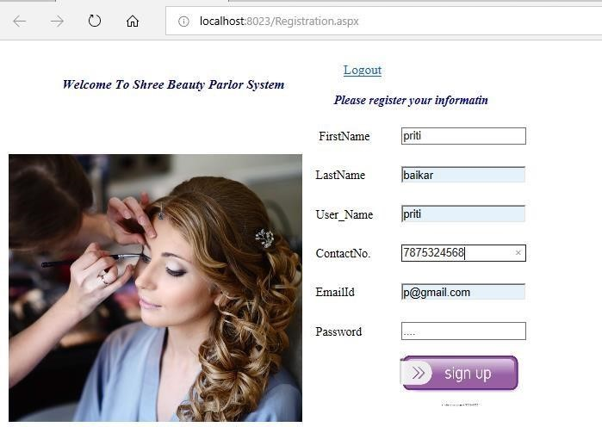

#### Home page

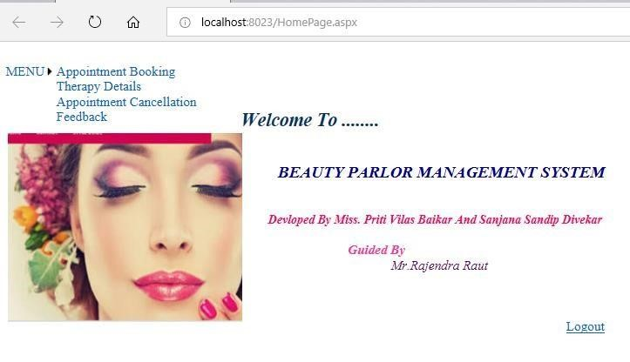

#### Appointment Booking Form

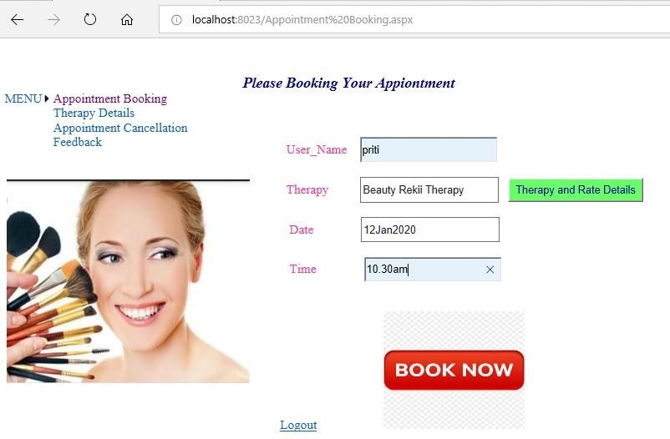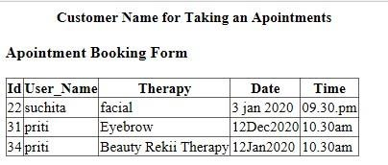

|  |  |
| --- | --- |
| **Therapy Details Form** |  |
|  | |

#### See Therapy Name and Rate

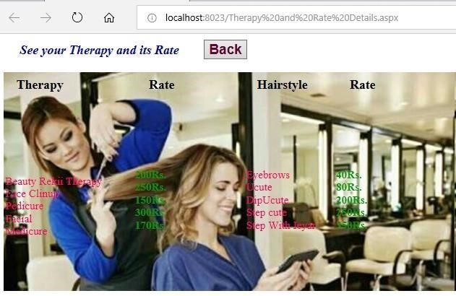

|  |
| --- |
| **Appointment Cancellation Form** |
|  |

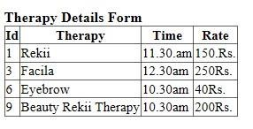

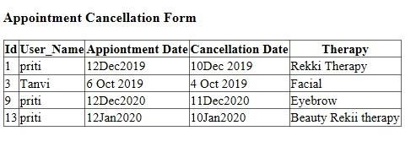

#### Feedback form

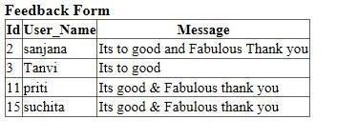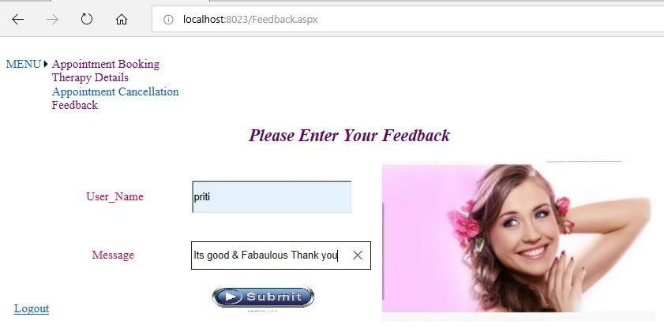

**Admin Form**

**Admin Registration**

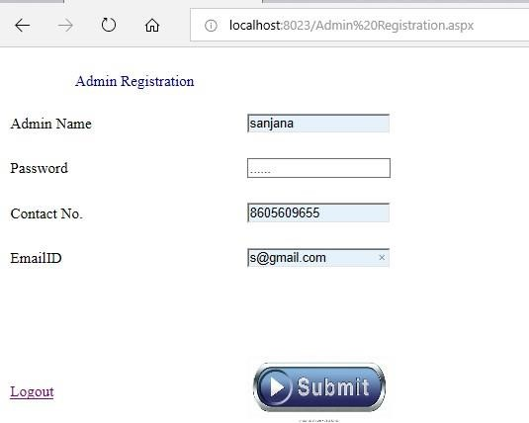

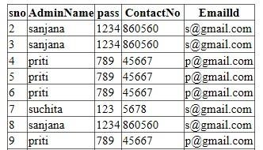

#### Admin Login

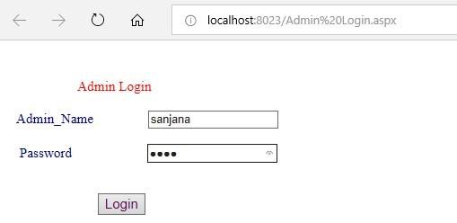

|  |  |
| --- | --- |
| **Admin Home Page** |  |
|  | |

#### SEE THERAPY NAME AND ITS RATE DETAILS FOR IMFOMATIOM

##### ABOUT ADMIN

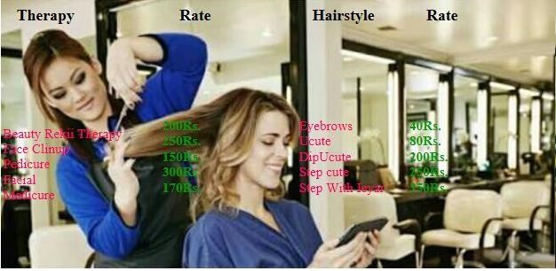

**CHAPTER 6**

### Conclusion and Future Work CONCLUSION

The present ‘Beauty Parlor Management System’ is useful for user, to keep the information and online registration in parlor system as well as to Chose your therapy and booking your appointment online. This system is developed as simple as possible to use. Being user friend software the user does not find any difficult in using it.

Keeping details, records of every customer is a very lengthy, costly and tedious job in manual system. This software overcomes these problems with less maintenance. In current system salon take appointment on register and it is very difficult to find old appointment details in this system.

All the requirement specifications was fallowed as for as possible and few additional features that were added that can make the application more user friendly and less complicated. The project “Beauty Parlor Management System” has been developed with the proper guidance.

We hope that “Beauty Parlor Management System” fulfils all the needs in possible manner.

### FUTURE ENHANCEMENT

Current developed has limited scope compared to other software. But, as this system is developed to make it more useful to manager so the operation this system are comparatively less powerful. So we are decided to increase the number of option in this application, by adding new menus each from and more than one way to make the same things.

#### Advantages

This system is very advantageous for those people who are working in Management Systems Because in this we can store large amount of data easily and search any record easily. There is no chances of lost any documents. And this system is portable to carry anywhere in cd or in removable disk.

Due to time constrains I was not able to make this system full-fledged. I will try to make so near future. The system still needs some programming.

I have developed this software as regards to the security and user flexibility. This software can also be modified as per as requirements of the individual’s logic.

Keeping the user’s needs the ‘Beauty Parlor Management Systems’ is developed. Hope that you are satisfied with our work and get as much pleasure out of it as. The user will find no difficulty in handling this system. But if so, then for their purpose the following are provided at every stage so that they can handle it easily. They are as fallows:

On every stage the user can find:

Error Massage.

We have developed this software as regards to the security and user flexibility. This software can also be modified as per requirements of individual institution.

**CHAPTER 7** **REFERANCE**

**REFERANCE**

### WWW.projectsolution.com WWW.msdn.com WWW.1000project.com WWW.visualstudio.in